SIMPLE POLLING APP
@CREATIVITY THINK (9483175986/7019689991)

ABSTRACT:
The Simple Polling App is a web-based dynamic application designed to facilitate quick decision-making and feedback collection through online polls. Users can create polls, participate by voting, and view live results instantly. Administrators have the ability to approve polls and export results to CSV for record-keeping. Developed using Django for backend processing and React with Recharts for frontend interactions, the system ensures real-time results, accuracy, and a lightweight user experience suitable for small teams or groups..

INTRODUCTION OF THE PROJECT:
Collecting opinions and making group decisions can be challenging without a streamlined process. Traditional methods like paper voting or informal discussions often lead to delays and inaccuracies. The Simple Polling App addresses these challenges by providing a centralized platform for creating polls, voting, and displaying live results. Users benefit from instant feedback visualization, while administrators maintain control over poll approval and result management..

PROJECT OBJECTIVES:

• Provide a platform to create, vote, and view polls
• Display real-time poll results for transparency
• Allow administrators to approve polls before activation
• Enable export of poll results for documentation or analysis
• Maintain a simple and user-friendly interface
• Ensure accurate vote counting and data integrity
• Deliver a lightweight system suitable for small teams
• Provide a scalable foundation for future enhancements

PROBLEM OF THE STATEMENT:
Small teams and groups often lack an efficient method for gathering opinions or conducting quick votes. Manual processes are prone to delays, errors, and miscommunication. The Simple Polling App automates poll creation, voting, and result visualization, reducing administrative effort, ensuring accuracy, and providing a clear, dynamic solution for group decision-making and feedback collection..

MOTIVATION OF THE PROJECT:
• To simplify group voting and feedback collection
• To provide real-time visibility of poll outcomes
• To ensure fair and accurate vote counting
• To allow administrators to control poll activation and manage results
• To provide a lightweight and user-friendly polling tool
• To enhance collaboration and decision-making in small teams
• To support future scalability for larger groups or organizations

BLOCK DAIGRAM OF PROJECT:

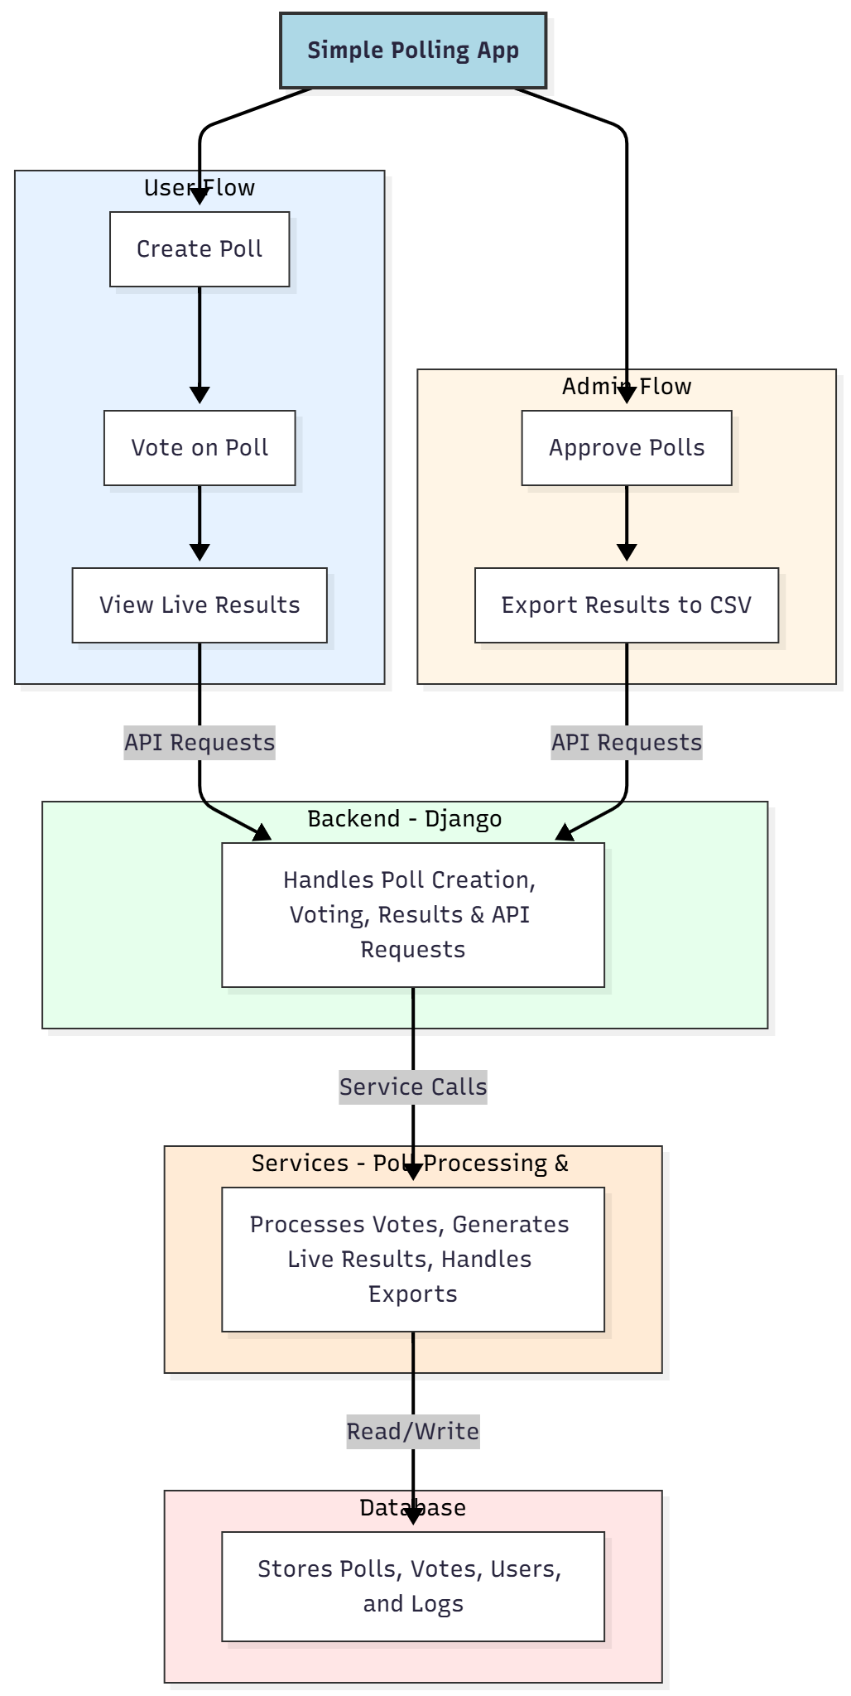

WORKING OF THE PROJECT:
Users create polls by providing questions and options. Participants vote on active polls, and results are updated in real-time using dynamic frontend components. Administrators approve polls before they go live to ensure relevance and correctness. Export functionality allows administrators to save poll results in CSV format for record-keeping or further analysis. The backend handles all poll data, voting logic, and API communication, while the frontend provides a responsive, interactive interface with live result visualizations..

SOFTWARE REQUIREMENT:
- Backend:
  - Python 3.x
  - Django
  - Django REST Framework
  - SQLite/PostgreSQL
- Frontend:
  - Node.js and npm
  - React.js
  - Axios
- Development Tools:
  - Visual Studio Code
  - Postman (for testing APIs)
  - Git/GitHub (for version control)
- Server/Deployment (Optional):
  - Gunicorn, Nginx, or Heroku/AWS for hosting

ADVANTAGES OF THE PROJECT:

• Quick and easy poll creation and voting
• Real-time visualization of results
• Simple interface for users and administrators
• Admin approval ensures poll validity
• Export results for documentation or analysis
• Lightweight and low-level complexity
• Reduces manual voting effort
• Scalable for small team use

APPLICATIONS OF THE PROJECT:
• Small team decision-making
• Quick feedback collection in offices or classrooms
• Event or activity voting
• Club or society poll management
• Surveys for short-term opinion gathering

REFERENCES:

- Django REST Framework Documentation — Django Software Foundation. Django Documentation. Available: https://docs.djangoproject.com/
- Django REST Framework. DRF Documentation. Available: https://www.django-rest-framework.org/
- React. React Official Documentation. Available: https://reactjs.org/docs/getting-started.html
- Redux. Redux Documentation. Available: https://redux.js.org/introduction/getting-started
- PostgreSQL Global Development Group. PostgreSQL Documentation. Available: https://www.postgresql.org/docs/
- MySQL. MySQL Reference Manual. Available: https://dev.mysql.com/doc/
- Git. Git Documentation. Available: https://git-scm.com/doc
- Node.js. Node.js Documentation. Available: https://nodejs.org/en/docs/
- Axios. Axios Documentation. Available: https://axios-http.com/docs/intro
- Socket.io Documentation – https://socket.io/docs/

